**Arijit Das**

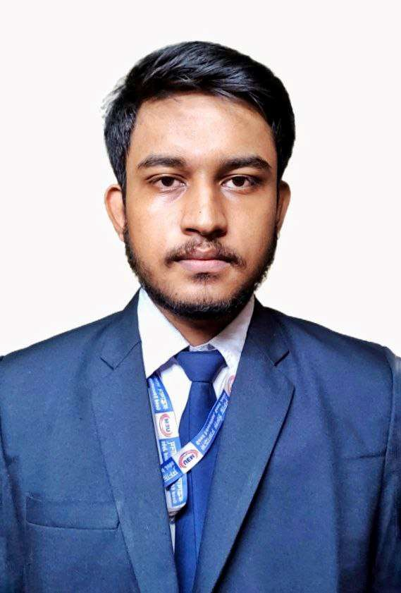

M | 21

arijitdas2k3@gmail.com | 9088918346

# PROFILE

* **Motivated and ambitious student, pursuing Bachelor of Technology degree from University of Engineering and Management Kolkata in the field of Computer Science.**
* **An enthusiastic fresher, showcasing a strong capacity to learn quickly and adapt to changes like new technologies and methodologies.**
* **Always having an aspiration to innovate and contribute towards the development of technology.**
* **Driven and focused individual with leadership qualities and teamwork skills.**

# ACADEMICS

|  |  |  |  |
| --- | --- | --- | --- |
| **Degree** | **University/Board** | **Year** | **%/** Aggregate Marks |
| **B.Tech in CSE (A.I. & M.L.)** | **University of Engineering and Management Kolkata** | **2021-Present** | **8** |
| 12th | Naihati Narendra Vidya Niketan (WBCHSE) | 2021 | 90.2% |
| 10th | Naihati Narendra Vidya Niketan (WBBSE) | 2019 | 89% |

**PROGRAMMING LANGUAGE PROFICIENCY**

* **Python**
* **C**
* **C++**

|  |  |
| --- | --- |
| **CERTIFICATIONS** |  |
| * **Coursera** –  1. **Google Data Analytics** 2. **Meta Database Engineer** 3. **IBM Cybersecurity Analyst** 4. **IBM Backend Development** | ***2024*** |
| **PROJECTS** |  |

# Missing Link prediction in Ecological Environment *2024*

# Hostel Utility Website *2023*

# Gym Management System web application *2022*

|  |  |
| --- | --- |
| **EXTRA-CURRICULAR ACTIVITIES** |  |
| * **Activities:**   Active participator in local blood donation camps, both as a volunteer and a donor.   * **Hobbies and Interest:**   Drawing, Writing, Swimming. |  |